**Smart Irrigation System using IoT**

T.E. mini-project report

By

Mansi Mange EU1174010

Shwetali Sahu EU2174007

Shubham Salvi EU1174031

Mitheel Sankhe EU1174052

Under the guidance of

Ms. Jessica Dias



**Department of Information Technology**

**St. John College of Engineering and Management**

**University of Mumbai**

**2019-20**

**ACKNOWLEDGEMENT**

Today, we cannot find appropriate words that will express deep sense of gratitude and satisfaction.

We are indebted to our inspiring Ms. Jessica Dias who has extended all valuable guidance, along with Mrs. Anita Chaudhari (HOD IT Dept.) in helping and giving constant encouragement through various difficult stages for development of the project.

We express our sincere gratitude to our respected principal Dr. G. V. Mulgund for encouragement and facilities provided to us.

We would also like to acknowledge the patience that our ever beloved parents have shown during our efforts and the encouragement we have received from them.

Thus we have fully obliged and convey our thanks to the teaching and as well as non-teaching staff of the department. Special thanks to all the lab assistants for helping us with problems developed in the lab and assisting, helping us to solve any problems generated on the spot. Last but not the least we would like to thank all direct and indirect identities of the college with whom we took the strides for this successful project.

**TABLE OF CONTENT**

**Page no.**

**1.0 INTRODUCTION…………………………………………....1**

1.1 Problem Statement……………………………………………......2

1.2 Scope of the Project………………………………………………2

1.3 Aim and Objective……………………………………………….2

**2.0 LITERATURE SURVEY……………………………...........3**

2.1 Smart Home Garden Irrigation System Using Raspberry Pi……..3

2.2 A Low Cost Smart Irrigation Control System…………………....4

2.3 IOT Based Flow Control System Using Raspberry PI………...…5

2.4 Mobile Integrated Smart Irrigation Management and Monitoring

System using IOT…………………………………………………....6

3**.0 SYSTEM METHODOLOGY…….………...........................7**

3.1 Hardware Requirements…………………………………............7

3.2 Software Requirements……………………………………….....7

3.3 System Architecture……………………………………...….......8

3.4 Implementation……………………………………………….....9

3.5 System Overview………………………………………………..9

3.5.1 Raspberry PI………………………………….….................9

3.5.2 Soil Moisture sensor……………………………………....10

3.5.3 Ultrasonic sensor……………………..…................…..........10

3.5.4 Relay………………………………………...…….…...........11

**4.0 RESULT………………………………………........................12**

**5.0 CONCLUSION AND FUTURE SCOPE …………....……...13**

5.1 References...……………………………………...…….…............14

**List of Figures**

**Page no.**

1. System Architecture………………………………….....……....8

2. Hardware connection...…………………………………..…......9

3. Soil moisture sensor……………………...………………........10

4. Ultrasonic sensor…….…………………...………………........11

5. Relay…………………………………………………………...11

6. Result of ultrasonic sensor…….……...…………......................12

7. Result of soil moisture sensor………………………………….12

**3.3 SYSTEM ARCHITECTURE**

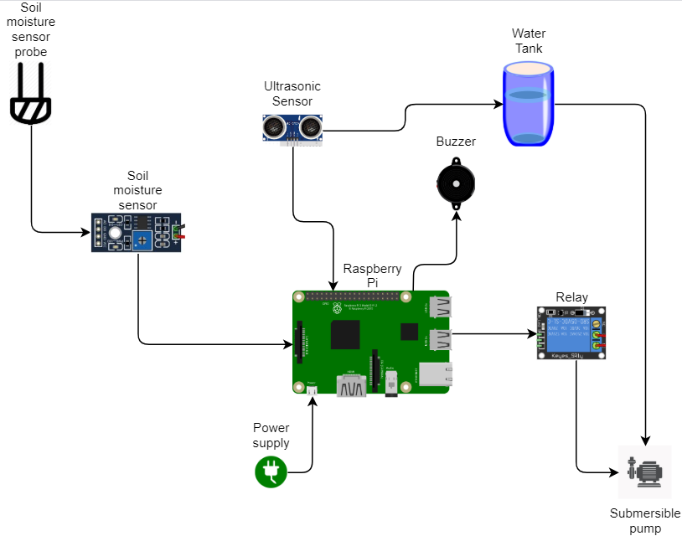

Figure 1: System Architecture

**3.4 IMPLEMENTATION**

The connection of all components of this project is been given below figure. There is raspberry pi, soil moisture sensor, ultrasonic sensor, relay and motor.

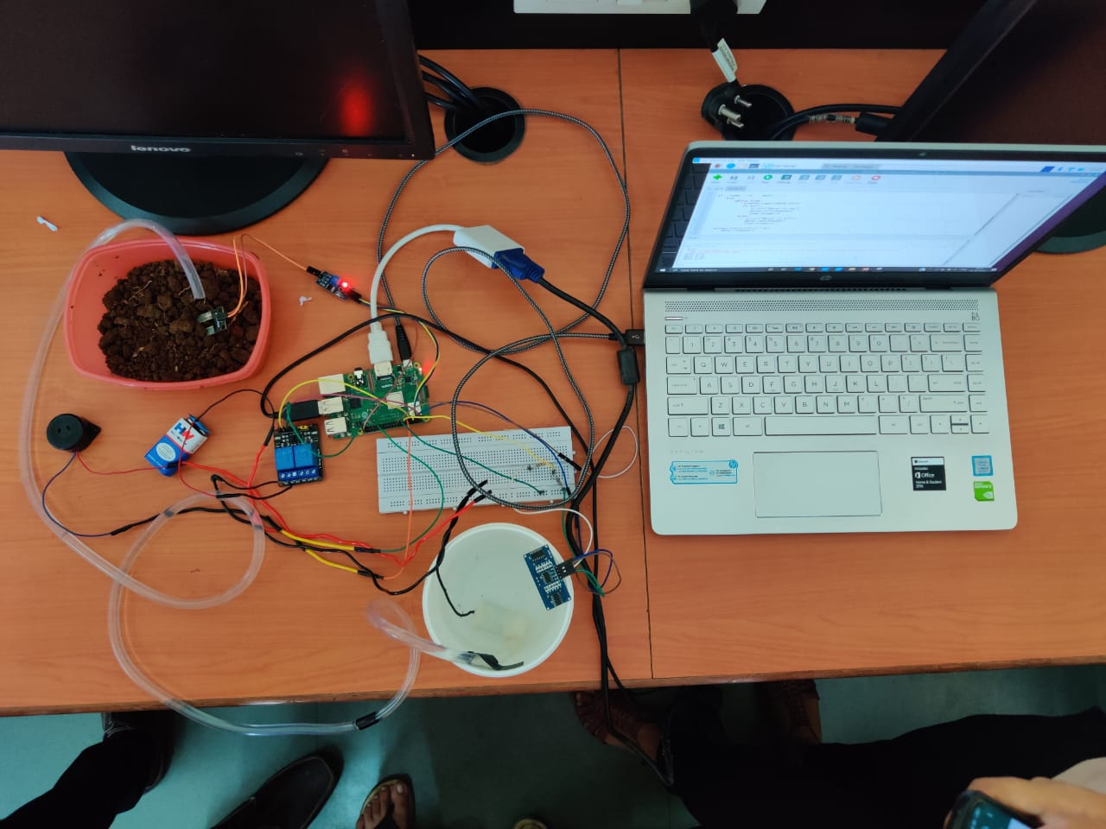

Figure 2: Hardware Connection

**3.5 SYSTEM OVERVIEW**

This system has function of the various components such as Raspberry Pi, soil moisture sensor, ultrasonic sensor and relay.

**3.5.1 RASPBERRY PI**

The sensor technology to automate irrigation improves water usage efficiency. The raspberry pi is a small single board computer which is been used to teach computer science. The raspberry pi is been used as computer where external memory can be used and it has four ports where any input devices can be connected. This project uses raspberry pi for easy process and installation.

**3.5.2 SOIL MOISTURE SENSOR**

Sensors are the devices which converts the physical parameter into the electric signals. The output of the sensor is analog signal; the signal is converted into digital signal and then fed into processor. The soil moisture sensor is used to measure the moisture content of the soil. The conductivity between the electrodes helps to measure the moisture content level. If the moisture content is low, the sensor sends signal to raspberry pi and then raspberry pi provides input signals to relay and it turns on the motor. After the detection of sufficient moisture content in the soil, the motor is turned off.

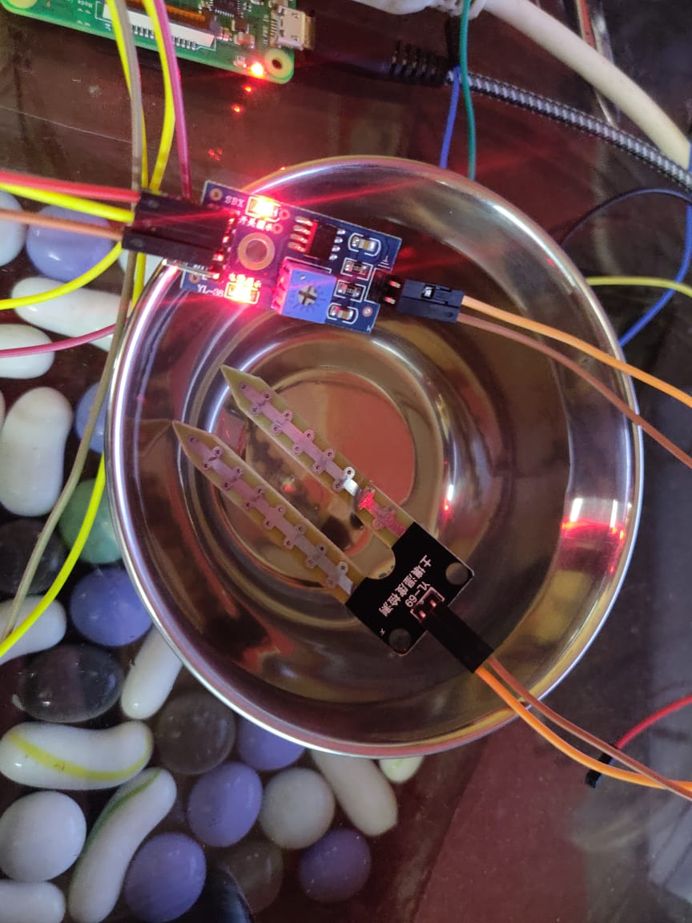

Figure 3: Soil moisture sensor

**3.5.3 ULTRASONIC SENSOR**

As the name indicates, ultrasonic sensor measure distance by ultrasonic waves. The sensor head emits an ultrasonic wave and receives the wave reflected back from the target. It measures the distance to the target by measuring the time between the emission and reception. In this system we use it to measure the distance from the ultrasonic sensor to the water present in the tank. Thus we can know, the tank from where the water is supplied to the plants has sufficient amount of water. The minimum length is predefined in the code. If the distance excess the value, ultrasonic sensor sends signals to raspberry pi and thus a buzzer beeps indicating the owner to fill the tank.

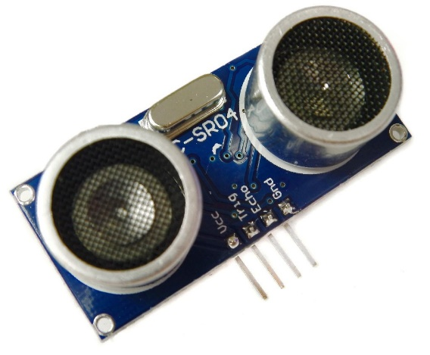

Figure 4: Ultrasonic sensor

**3.5.4 RELAY**

A relay is an electrically operated switch. It consist of a set of input terminals for a single or multiple control signals, and asset of operating contact terminals. The switch may have any number of contact in multiple contact forms, such as make contacts, break contacts, or combination. In our system we use to switch on or switch the motor.

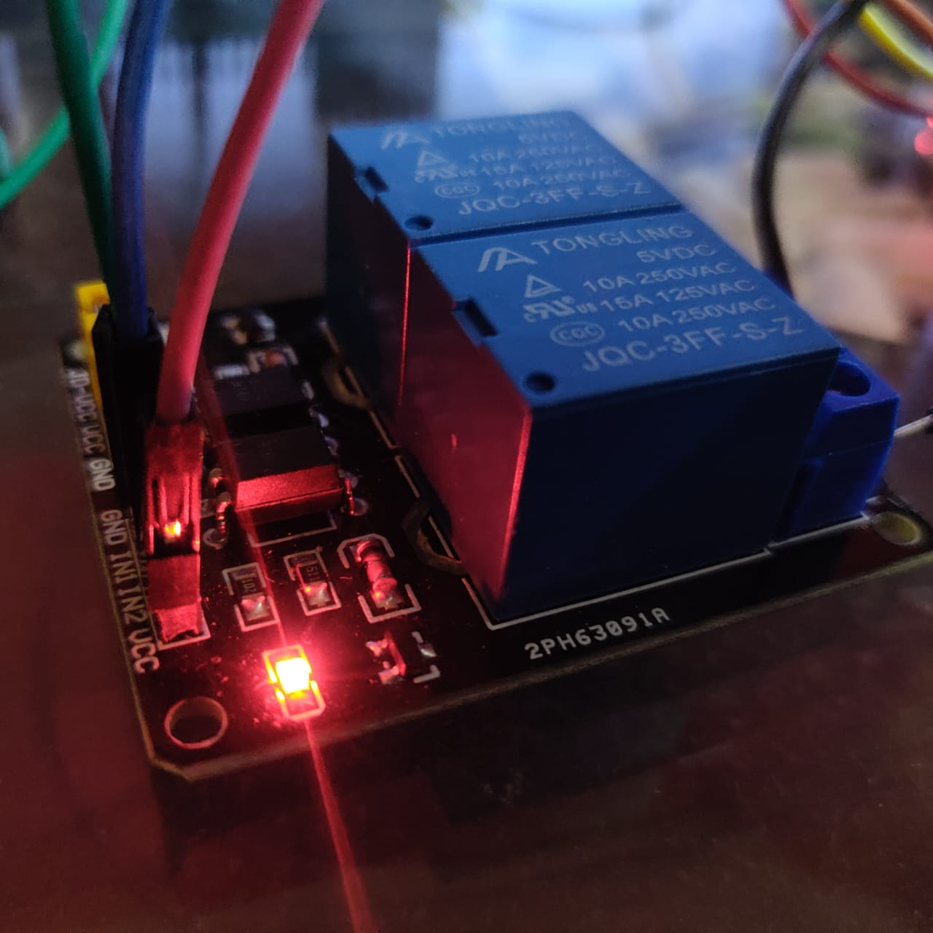

Figure 5: Relay

**4.0 RESULTS**

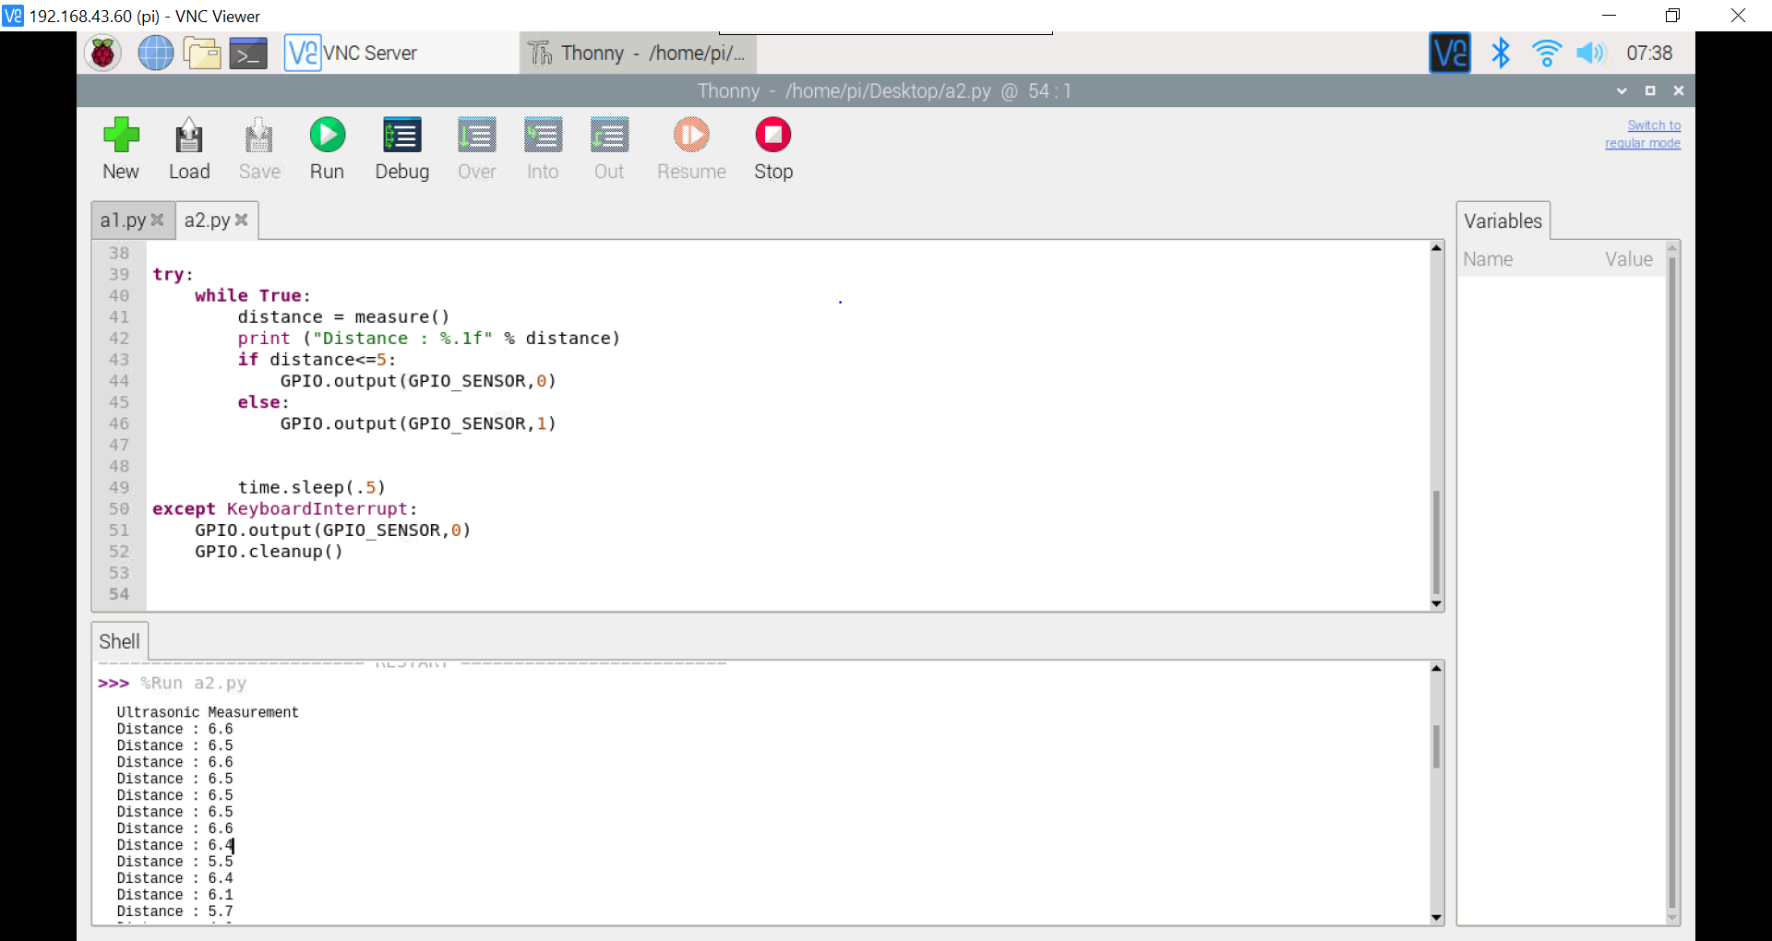

Figure 6: Result of ultrasonic sensor

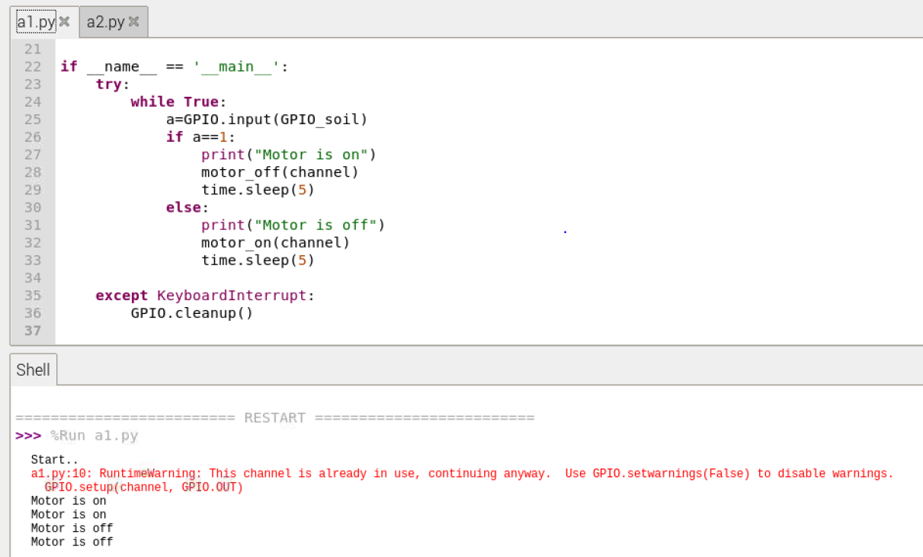

Figure 7: Result of soil moisture sensor

**5.1 REFERENCES**

[1] S.N. Ishak, N.N.N.Abd Malik, sN.M. Abdul Latiff, N. Effiyana Ghazali, M. A. Baharudin “Smart Home Garden Irrigation System Using Raspberry Pi”, IEEE 13th Malaysia International Conference on Communication, 28-30 Nov. 2017.

[2] Chandan kumar Sahu, Pramitee Behera, “A Low Cost Smart Irrigation Control System”, International Conference on Electronics and Communication System, 2015.

[3] Shavarsidha Gunde, Prof. A. K. Chikaraddi, Dr. V. P. Baligar, “IOT Based Flow Control System Using Raspberry PI”, International Conference on Energy, Communication Data Analytics and Soft Computing, 2017.

[4] Vaishali S, Suraj S, Vignesh G, Dhivya S, Udhayakumar S “Mobile Integrated Smart Irrigation Management and Monitoring System Using IOT”, International Conference on Communication and Signal Processing, April 6-8 ,2017, India.

[5] Website: www.cyber-omelette.com